Game Design Document

Fill up the following document

1. Write the title of your project.

.Planet Crush

1. What is the goal of the game?

.Save the Planet from the asteroids.

1. Write a brief story of your game.

.In my game “Planet Crush”,There are asteroids which hurldel towards the planet.The spaceship i.e.,the player has to defend the planet by destroying the asteroids.This game requires extreme level of focus.

What I mean to tell the world by this game is,that if you are focused on what you are doing,you can overcome anything.On that state,nothing is impossible for you.

1. Which are the playing characters of this game?

* Playing characters are the ones who respond to the user based on the input from the user.
* Cars, monkeys, dinos, wizards, etc., are the playing characters in the game.

|  |  |  |
| --- | --- | --- |
| Number | Character Name | What can this character do? |
| 1 | SpaceShip | Shoot Bullets |
| 2 |  |  |
| 3 |  |  |
| 4 |  |  |
| 5 |  |  |
| 6 |  |  |
| 7 |  |  |
| 8 |  |  |

1. Which are the Non-Playing Characters of this game?

* Non-Playing characters are the ones that don't have an action or behavior when the user interacts with the game.
* Hurdles, stones, bananas, coins, etc., are non-playing characters in the game.

|  |  |  |
| --- | --- | --- |
| Number | Character Name | What can this character do? |
| 1 | Asteroids | Hurdle towards the planet |
| 2 |  |  |
| 3 |  |  |
| 4 |  |  |
| 5 |  |  |
| 6 |  |  |
| 7 |  |  |
| 8 |  |  |

Draw your imagination of this game. What does this game look like?

* Draw the game either on your computer or on paper.
* Add images of the game scenes to show each of the playing and non-playing characters at least once.

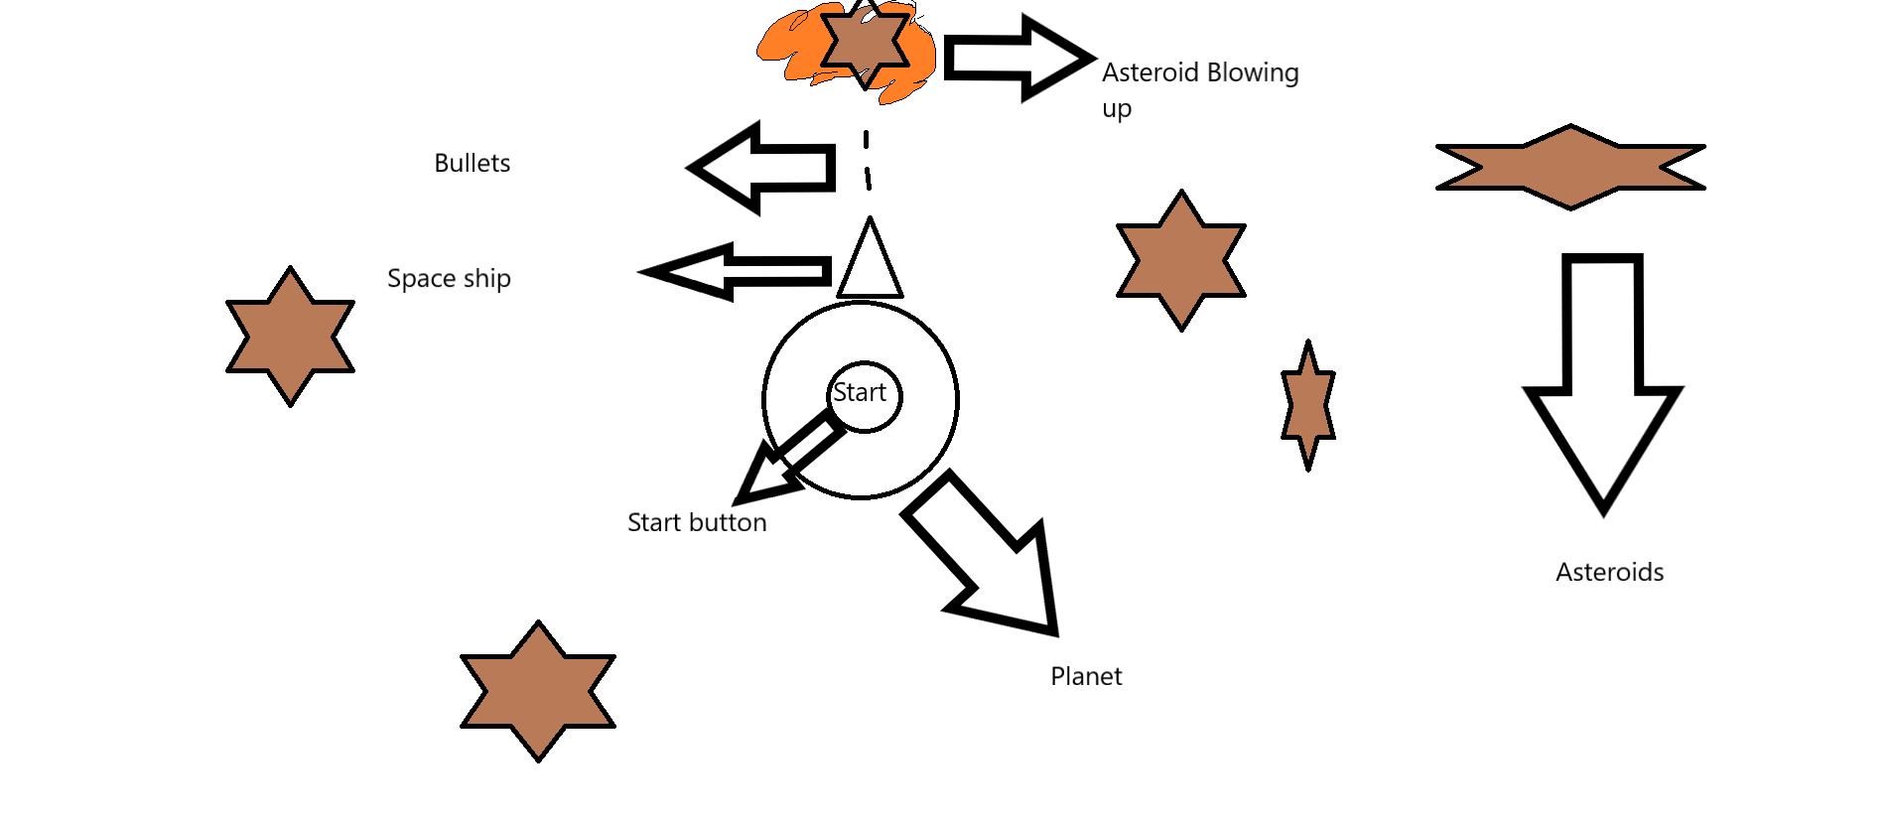

How do you plan to make your game engaging?

.As the game progresses,the number of the asteroids will increase making it hard,fun and exciting for the player.

I have also added a scoreboard which shows the highscore of the player,so that to keep the player motivated.